Developer Guide

Project Overview
The “BOOK HIVE” application is a full-stack, feature-rich web platform designed for readers, authors, and book enthusiasts to explore, purchase, and manage books online. The system combines the functionality of an e-commerce bookstore with intelligent recommendation features to deliver a personalized and interactive reading experience.
Through user authentication, personalized recommendations, book categorization, reviews, and wishlist features, the app simplifies the process of discovering and buying books. It connects readers with literature tailored to their tastes and promotes new authors and titles through curated listings and interactive sections.
Built with Flutter (front-end) and Firebase (back-end), the project ensures scalability, real-time data synchronization, and secure user management. The modern interface is fully responsive, providing a seamless experience across mobile and desktop devices.
Key highlights:
- Personalized reading and book discovery experience
- Real-time synchronization with Firebase
- Integrated cart, wishlist, and order management
- Secure login and authentication system
- Admin panel for managing books and users
Project Deliverables
Your final submission should be a complete package that demonstrates both the functionality and design of the application. The mandatory deliverables include:
● Project Report
A comprehensive report covering the following:
- Problem Definition: Readers often struggle to find books that match their specific interests and reading goals. BOOK HIVE addresses this by offering an intelligent, organized, and interactive book discovery and purchasing platform.

- Design Specifications: The application follows a client-server architecture. The front end (Flutter) communicates with Firebase services for data management, authentication, and real-time updates.
- Diagrams:
  - Use Case Diagram — showing interactions between users, admins, and the system.
  - Data Flow Diagram — illustrating data movement between modules like Login, Book Details, Cart, and Orders.
  - ER Diagram — describing entities like Users, Books, Orders, and Wishlist with relationships.
- Database Design:
Firebase Firestore collections include:
  - Users (userID, name, email, password, role, profilePic)
  - Books (bookID, title, author, genre, price, image, description, stock)
  - Cart (cartID, userID, bookID, quantity)
  - Orders (orderID, userID, bookIDs, totalAmount, status, date)
  - Wishlist (wishlistID, userID, bookID)
- Test Data:
Sample user accounts, books, and orders used during development and testing.
- Installation Instructions:
  - Install Flutter SDK and VS Code / Android Studio.
  - Clone or extract the project folder.
  - Run flutter pub get to install dependencies.
  - Connect the app to your Firebase project (update google-services.json).
  - Run using flutter run or build with flutter build apk.
- User Credentials:
  - Admin: admin@bookhive.com / 123456
  - User: user@bookhive.com / 123456

● Source Code & Database Files
- The entire BOOK HIVE project (source code + assets + database structure) is provided in a .zip file.
- A ReadMe.doc file is included, explaining setup instructions and assumptions.
- Firebase database rules and structure (Firestore collections) are defined in the documentation.

● Video Demonstration
A mandatory .mp4 video is provided, showcasing the full functionality of the application — from user registration and book browsing to cart management and order placement.
● Sitemap
The sitemap visually represents the navigation flow of the application:
Home → Categories → Book Details → Cart → Checkout → Orders / Profile → Logout For the Admin:
Admin Dashboard → Manage Books → Manage Orders → Manage Users

Home
├── Login / Register
├── Categories
│ ├── Fiction
│ ├── Non-Fiction
│ ├──romance
│ └── fantasy
│ └──best seller
│ └──new arrival
│ └──threater
├── Book Details
│ ├── Add to Cart
│ └── Add to Wishlist
├── Cart
│ └── Checkout
├── Orders
├── Profile
└── Admin Panel
├── Manage Books
├── Manage Orders
└── Manage Users

Functional Requirements
The BOOK HIVE system must perform the following key actions and behaviors:
- User Authentication: Allow users to register, log in, and manage their profiles securely via Firebase Authentication.
- Book Management: Admin can add, edit, and delete books from the database.
- Search & Filter: Users can browse books by title, author, genre, or price.
- Cart & Checkout: Users can add books to their cart and proceed to checkout to confirm purchases.
- Wishlist: Users can save favorite books for later.
- Order Management: Both users and admins can view order history and status updates.
- Personalized Recommendations: Suggest books based on genre preferences or past activity.
- Notifications: Real-time updates for order confirmations and changes.
Non-Functional Requirements
The BOOK HIVE platform focuses on key non-functional goals to ensure performance and reliability:
- Performance: The application must load quickly, with minimal latency between actions. Firebase ensures fast data retrieval and synchronization.
- Scalability: Firebase backend supports automatic scaling for concurrent users and large datasets.
- Security:
  - Firebase Authentication for secure login and registration.
  - Firestore security rules to restrict unauthorized data access.
  - Encrypted communication via HTTPS.
- Usability: The Flutter-based UI ensures a modern, clean design with easy navigation and clear feedback on user actions.
- Maintainability: Modular and reusable code structure with separate files for models, services, and UI components.
- Reliability: Offline support ensures data persistence when connectivity is lost.
Hardware and Software Requirements
Hardware
- Server: Firebase Cloud Hosting (no manual server required).
- Client (User Device):
  - Processor: Minimum 2.0 GHz
  - RAM: Minimum 4 GB
  - Storage: 200 MB free
  - Operating System: Android 8.0+ / Windows 10+ / iOS 13+
Software
- Frameworks:
  - Frontend: Flutter SDK (Dart language)
  - Backend: Firebase (Firestore, Auth, Storage, Cloud Functions)
- Database: Google Firebase Firestore (NoSQL)
- Development Tools:
  - Visual Studio Code / Android Studio
  - Git for version control
- Operating System: Windows / macOS / Linux
- Additional Dependencies:
  - cloud_firestore, firebase_auth, firebase_storage, provider, fluttertoast, image_picker, razorpay_flutter

Summary
The BOOK HIVE Developer Guide documents the design and implementation of a full-stack Flutter + Firebase web application for book discovery and e-commerce.
Key takeaways:
- The project provides a complete ecosystem for users to explore, purchase, and manage books.
- It ensures scalability, performance, and security through Firebase integration.
- Deliverables include a full source code package, video demonstration, sitemap, and technical documentation.
- The structured architecture supports future enhancements such as community reviews, reading challenges, and advanced AI recommendations.

PRESENTED BY:
LAIBA ,DUA ,RIDA ,SABA

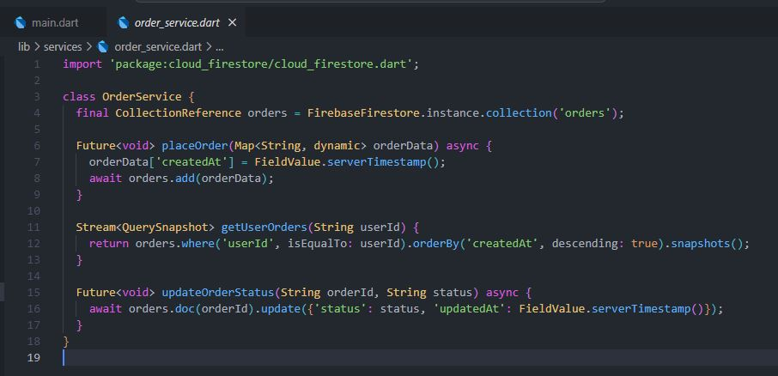
1:ORDER SERVICE DART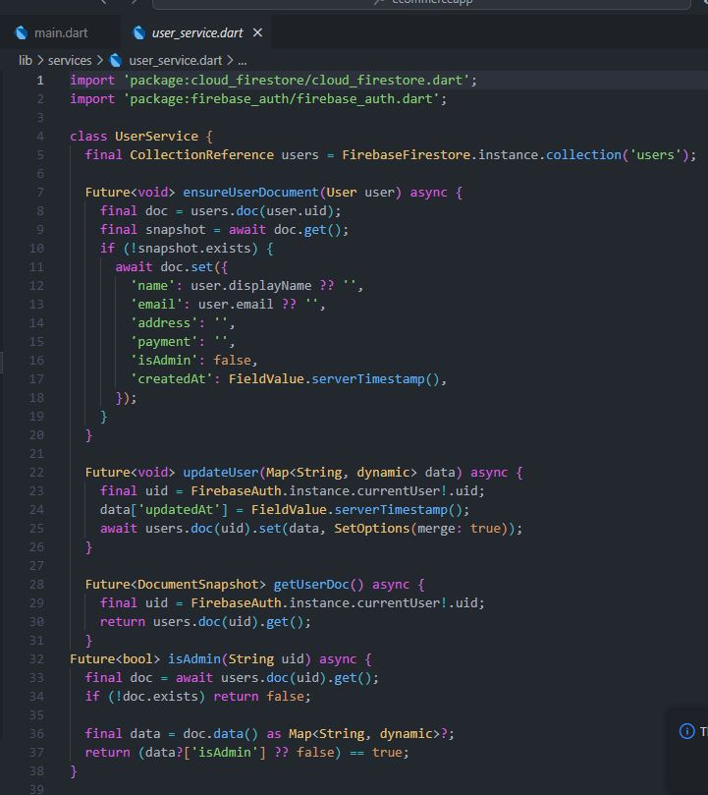2:USER SERVICE DART

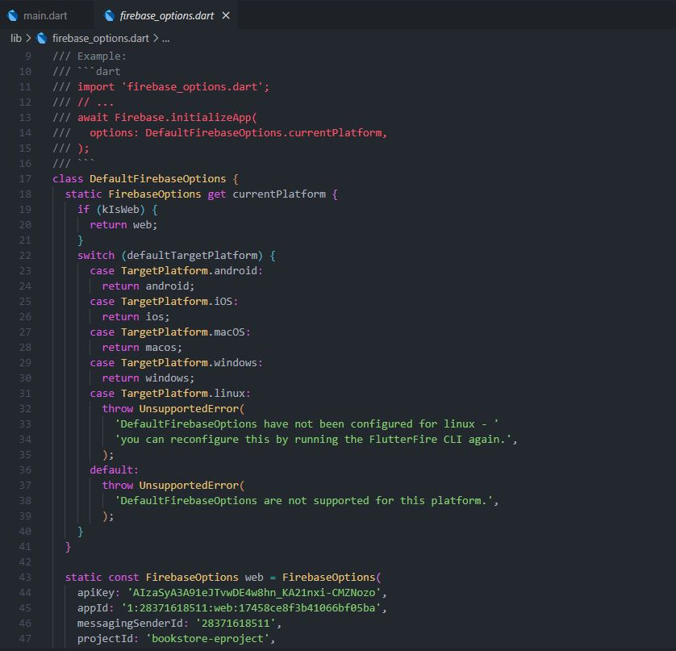 3:FIREBASEOPTION.DART(1)

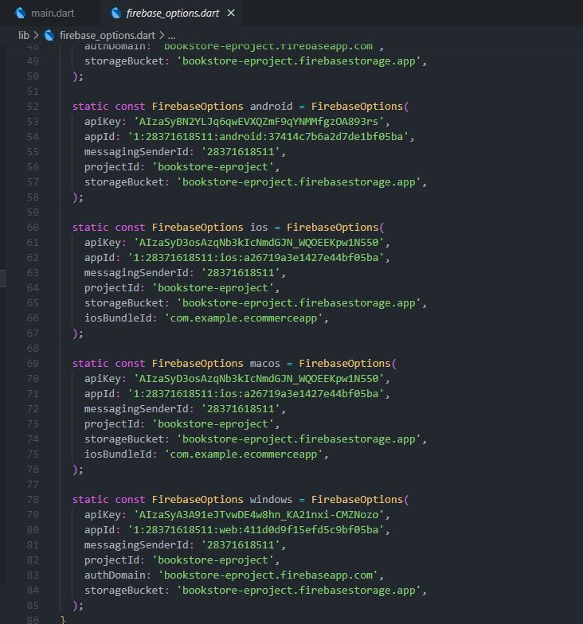 4:FIREBASEOPTION.DART(2)

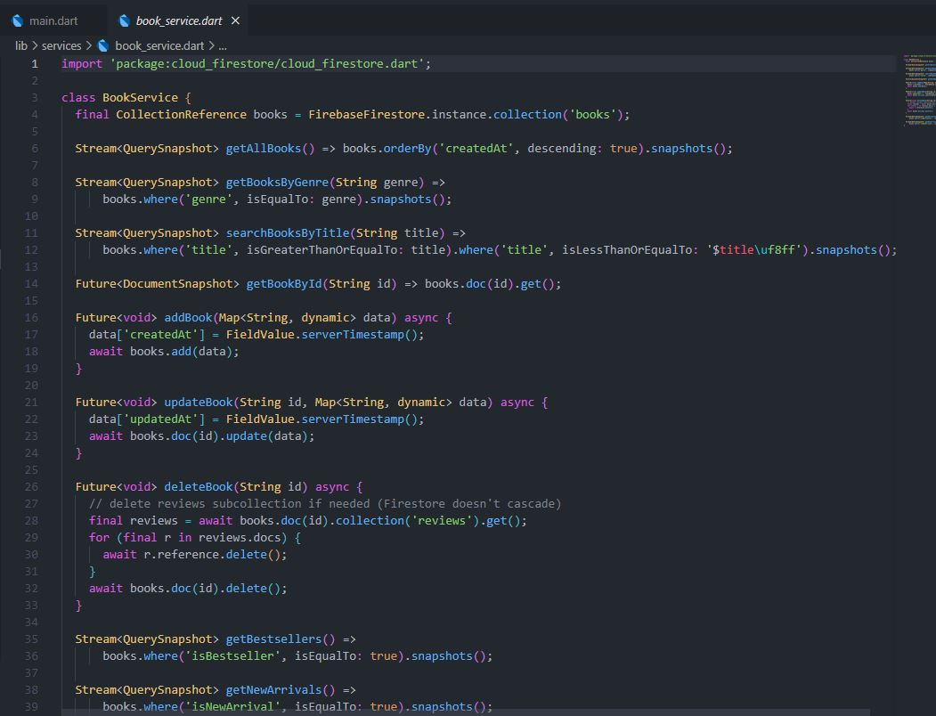
5:BOOKSERVICE.DART

